Integer geometries inside magnetic elements
For the IEEE Magnetics Society Conference on April 25, 2022 in New York City
Magnetic Frontiers, Quantum Technology
Alan Folmsbee, December 21, 2021

Abstract

The proton locations in the atomic nuclei are now known, based on theoretical physics. The shape of the iron nucleus was discovered first, and then the shapes of all other elements were predicted. The protons form lines of protons in many elements. Those lines of protons create larger scale topologies, including rings of protons in atomic nuclei. Iron has two coaxial rings of protons with 12 protons in each ring. Cobalt has the same description. Gadolinium has two rings of 18 protons. The nuclear structure is shaped like a magnetic transformer. The theory is called “the pyramidal cube theory of the static nucleus”. The integer geometries in a GdFeCo alloy are used in this paper to explain the picosecond reversal of magnetic poles using a flash of light. Figures show the lines of flux from each nucleus to electrons that are interacting with lines of flux from other nuclei. The 75% iron and cobalt, with 25% gadolinium, was experimentally determined to be the best allocation of the three elements. That alloy with a 3:1 ratio is consistent with the 18 lines of flux from a central Gd atom interdigitating with 18 lines of flux from three atoms of Fe or Co which surround the Gd atom. Knowing the theoretical charge distributions on the nuclei can provide explanations and predictions for spintronics experiments. For example, chromium has two rings of 10 protons that partially overlap. That explains the antiferromagnetic property of Cr. Neodymium is also evaluated to explain why it is beneficial to iron magnets. Geometric reasoning is used for sphere stacking, instead of using the algebra of Hamilton, Gell-Mann, and Schrödinger for theories of nuclear structure. Those old methods cannot predict that iron has two rings of protons, but the new methods have succeeded.

Introduction to the static nucleus theory of the pyramidal cube
In 2017, the author discovered the shape of the iron nucleus. A theory was discovered that explains many properties of iron and all elements. It uses a static nucleus with fixed locations for the protons and neutrons. In the past, electrons were said to cause ferromagnetism, because of their spins. The nucleus was not mentioned as being different than the nucleus of copper. Progress has been made for the explanation. The spins of the electrons were the same direction because the protons in the iron nucleus form rings of twelve protons. The proton current determines the spins of electrons, relative to each other.
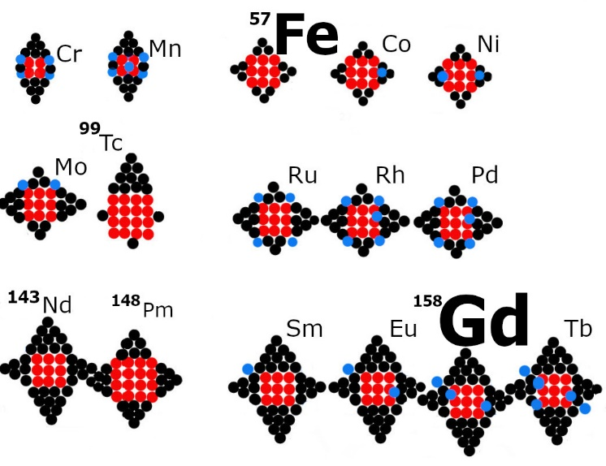
Figure 1: part of a periodic table of nuclear silhouettes showing iron and gadolinium [3]

The silhouettes in Fig. 1 use black circles for baryons, red circles for a simple cubic lattice of baryons, and blue circles for protons added on to the foundation elements. There are nineteen foundation elements [4] that are the basis for ninety incremental elements. Iron is the foundation for cobalt. These are transition metals (TM). Cerium is the foundation element for Gd, a rare earth element (RE).

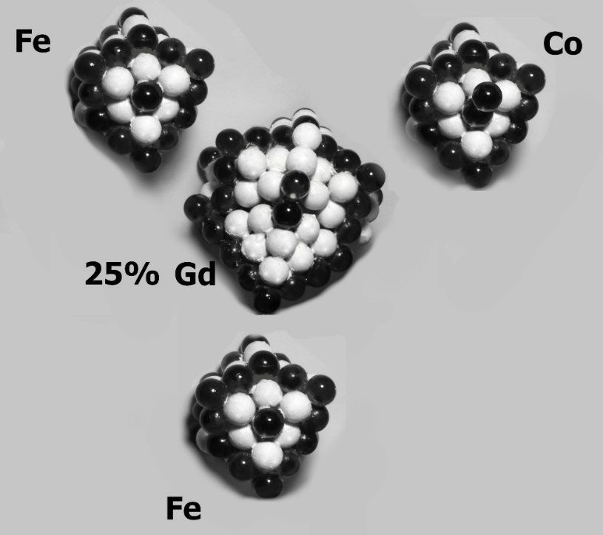

Figure 2: nuclei in an alloy for a nanotechnology thin film

The models of three elements in Fig. 2 use dark protons and white neutrons. Fe has two rings of protons. Each ring has twelve protons [5]. On the axis of the ring is a lone proton that is coaxial with both rings. Co is like Fe, but on the axis are two protons. Gd has eighteen protons in one ring and eighteen more in a second ring. Positioned coaxially with both proton loops, are two protons. A superconducting current can flow in either ring, in either direction. The electron eddy current associated with this atom has electron motions in the same direction as the proton current (Lenz’s Law). A spin current flows in some cases and electron motion can occur as an eddy current if the flux density changes in time. A line of flux connects each proton to one electron at all times, even for a plasma. That pairing can change during an ohmic cycle so a different electron is paired with the proton.
The alloy for this paper is 25% Gd and 75% Fe and Co. In [1, 2] a picosecond flash of light can reverse the poles in the alloy. The north poles become south poles and vice versa. Notice in Fig. 3 that the twelve lines of flux from three TM atoms interdigitate with the eighteen lines from the RE element. Half of the twelve lines of TM atom face the Gd, so the Gd is surrounded by eighteen lines from the Fe and Co. The stoichiometry of 3::1 for the TM to RE is specifically recommended in [2]. That alloy composition ratio supports the proposed facts that iron has 12 protons in each ring and Gd has 18.
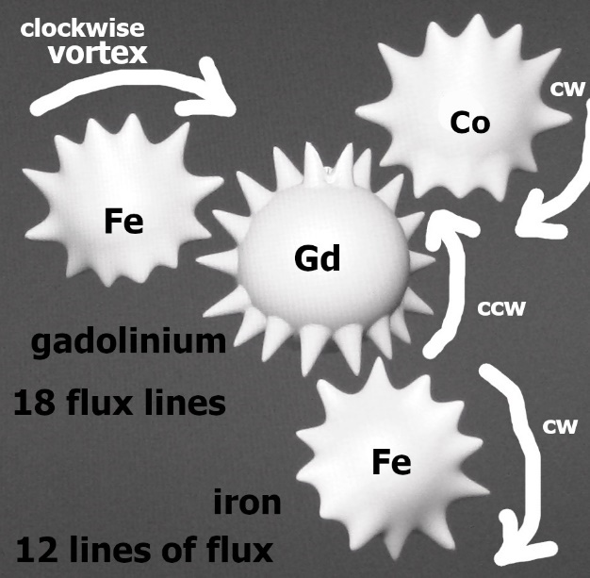
Figure 3 before laser flash of light, Fe has south pole, Gd has north pole

The four atoms from Fig. 2 are represented in Fig. 3 with lines of flux drawn. The counter-clockwise (CCW) magnetic vortex of flux lines for Gd are the north pole facing the reader. The clockwise (CW) vortex for the Fe and Co atoms makes the south poles. A spin current of electrons is circulating, not a charge current. Each magnetic flux vortex in Fig. 3 goes the same direction as the proton current in a nucleus, before the picosecond pulse of light. The lines of flux slide past each other without a loss of anything. They are like cogs in a gear.
Lines of flux do not move through other lines unless an ohmic cycle occurs. That is called the non-crossing law. A proton current in a direction determines that the paired electrons are moving in the same direction.
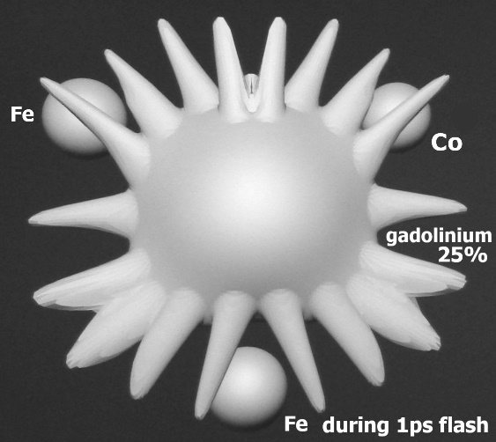
Figure 4: during a sub-picosecond pulse of light [7], iron loses its flux first

During the picosecond of illumination (Fig. 4), the lines disappear rapidly for Fe and Co, but slowly for Gd. The Gd flux lines continue their CCW rotation as a magnetic vortex. The electrons that were paired with the Fe and Co protons have become unpaired and re-paired with different nuclei that are not in Fig. 4.
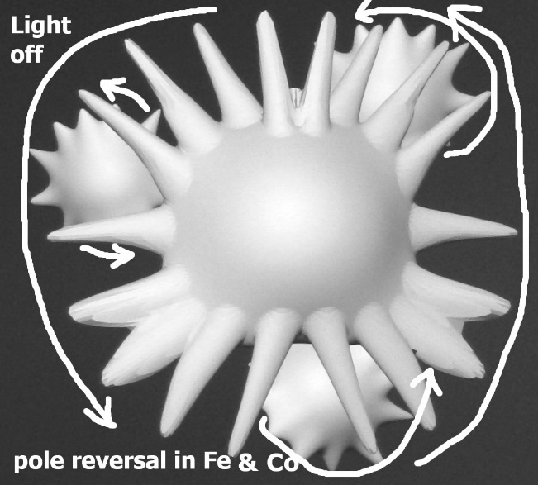
Figure 5: during the transition from light to dark, iron gets its flux back

All four atoms in Fig. 5 have north poles for a short time (CCW). The Gd drives the Fe lines initially so a CCW vortex exists in every Fe and Co atom. Then, the iron atoms overpower the Gd atom (Fig. 6) so the Gd vortex direction is reversed. The flux vortexes act like they have discrete cogs in a gear train. The quantized nature of the vortex is due to the proton-electron pairs that form the lines of flux. The Gd atom obtains a pole reversal to become a south pole because the Fe and Co atoms force the Gd vortex to reverse direction.
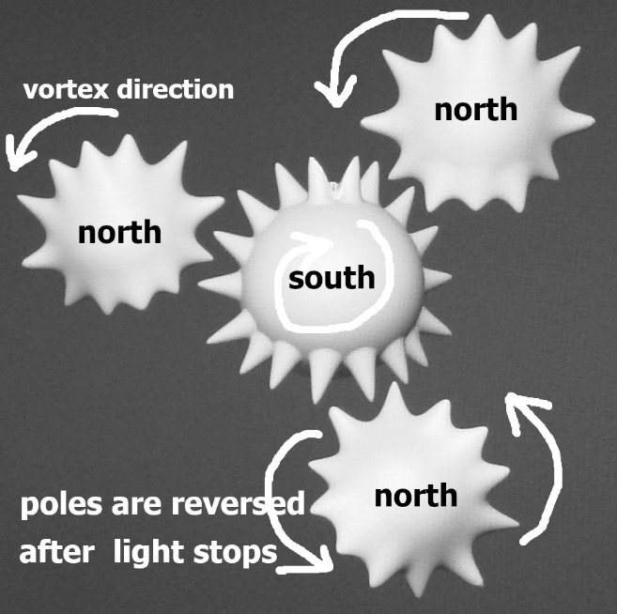
Figure 6: after the light stops, the Gd pole is eventually reversed by the Fe and Co.

After the light is darkened, the non-crossing law [7] allows for the stable north poles of the Fe and Co, but the south pole on the Gd. The three TM atoms drive the Gd to reverse its north pole to become a south pole. This is an antiferromagnetic material, like chromium [8].

Conclusion
The lines of flux from Gd persist for a longer time, when illuminated, than do the lines of flux for iron and cobalt [8]. That allows the Gd flux vortex to grow and encompass the TM atoms, while continuing to possess a north pole. Like a planetary gear, the wide Gd flux vortex drives the small TM electron groups to have the same pole as the Gd atom. All four atoms have north poles (Fig. 5). When darkness is restored, the iron lines of flux are re-established under the influence of the rotation of the Gd vortex. After the Fe atoms have their vortexes established, they can overpower the Gd vortex to reverse the pole on the Gd atom. The integer numbers of 18 and 12 lines of flux, combined with the 25% and 75% alloy composition, support the idea that ferromagnetic elements have integer geometries in their physical realities. This implies that the static nucleus theory can be applied to Cr and Nd, also [8], to predict how alloy compositions of any elements will affect magnetic properties.
There are some light elements with single rings of protons. Chlorine has a ring of eight protons. Magnesium, twelve in a ring [9]. Vanadium has ten in a ring [10]. Manganese has ten in a ring. Germanium has twenty protons in a ring. Molecular ferromagnets can be attempted using this knowledge. Neodymium has 18 protons in each of two rings, like Gd. But Nd does not have a proton on the axis of the rings, in the plane of the ring. That explains how Nd could contribute 36 extra flux lines to the Fe atom, which only has 12 lines of flux per pole. That allows for a maximum of four times the flux density from a neodymium-iron magnet compared to an iron bar magnet.

References
[1] “Unifying femtosecond and picosecond single-pulse magnetic switching in Gd-Fe-Co”
By F. Jakobs, T. A. Ostler, C.-H. Lambert, Y. Yang, S. Salahuddin, R. B. Wilson, J. Gorchon, J. Bokor, and U. Atxitia, PhysRevB.103.104422 published in 2021

[2] Transient ferromagnetic-like state mediating ultrafast reversal of antiferromagnetically coupled spins | Nature
I. Radu, K. Vahaplar, C. Stamm, T. Kachel, N. Pontius, H. A. Dürr, T. A. Ostler, J. Barker, R. F. L. Evans, R. W. Chantrell, A. Tsukamoto, A. Itoh, A. Kirilyuk, Th. Rasing & A. V. Kimel, March 30, 2011.

[3] Periodic Table of Nuclear Silhouettes, version of November 21, 2021,
http://pyramidalcube.blogspot.com/p/periodic-table.html

[4] “Magnetism from iron’s nuclear structure”, Journal of Nuclear Physics, March, 2019
by Alan C. Folmsbee, Hartford, Connecticut, USA

[5] Charge distributions on the nuclei, Data set six: Fe to Ga
Published on Amazon’s Kindle Direct Publishing, 2021

[6] Abstract units of measure using the mass equals area theorem:
Gravity Volume Theory (fcgravity.blogspot.com) , use the “Units of Measure” link.

[7] Nuclear structure from sphere stacking by Alan Folmsbee, 2021, ISBN 13: 979-8520734215

[8] “Antiferromagnism in the Cr nucleus”, Journal of Nuclear Physics, July, 2021
by Alan C. Folmsbee

[9] Charge distributions on the nuclei, Data set three: Ne to Si
Published on Amazon’s Kindle Direct Publishing, 2021

[10] Charge distributions on the nuclei, Data set five: Ar to Mn
Published on Amazon’s Kindle Direct Publishing, 2021

